Adagio School of Performing arts

CURRICULUM INTENT

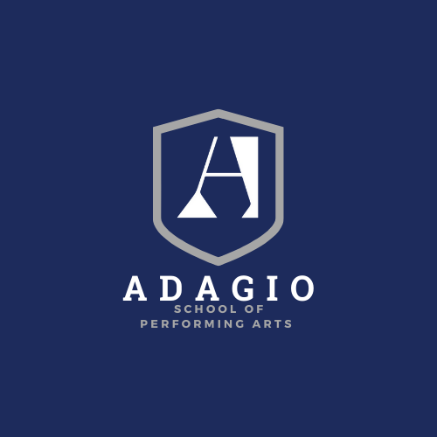

Curriculum Intent
Our curriculum is planned with the intent to:
- Provide all students with a broad and balanced curriculum throughout their learning journey at Adagio School of Performing Arts.
- Enable students to develop skills and achieve excellence in Jazz, Tap and Musical Theatre to foster versatile performers.
- Prepare students to progress to elite institutions for further training in Classical Ballet/Dance/Musical Theatre and, ultimately, pursue a professional career in dance.
- Provide a broad, balanced and enriching academic education, which equips students with the skills, knowledge and qualifications to pursue a different path at 16+ or later in life.
- Adhere to, or go beyond, the National Curriculum in most subjects to ensure greater depth and breadth in learning.
- Enable all students to build and learn new knowledge and skills on their prior knowledge; thus allowing students to develop deep learning of knowledge and skills.
- Provide students with engaging lessons taught by highly skilled expert teachers with opportunities for experiences beyond the classroom.
- Allow students to learn from mistakes, using assessment at the most appropriate time to identify and address gaps in knowledge.
- Achieve the highest possible results in national tests.
- Prepare students for the next phase of their education or employment and life in modern Britain, taking account of pupils’ aspirations, the local, national and global job markets.
- Develop students’ characters and add to their cultural capital through Classical Ballet and Performing Arts.
- Foster a strong work ethic amongst students.
- Ensure diversity is celebrated to ensure all students feel welcomed,
supported and valued in the school community.
14.Develop an array of reading strategies to advance literacy skills and access texts at all levels.

Adagio School of Performing Arts selects students on the basis of their aptitude for Classical Ballet and Performing Arts. They are assessed on their performance in ballet and jazz class at preliminary and final auditions along with academic tests in English and Maths. The physical auditions take the form of a visual assessment of the student’s physical, musical and artistic ability and perceived potential as a performer. The final audition is supplemented by a physiotherapy/general health assessment.

Academic Curriculum
CURRICULUM OVERVIEW
The National Curriculum is taught from Years 7 to 11.
- In Year 7 all students follow courses in: English, Mathematics, Science, a Modern Foreign Language, Geography, History, Art, Music, IT and PHSE RSE.

- Year 8 students follow a similar pattern. This structure is continued into Year 9.

- During Year 9, the students choose the subjects they wish to continue with, or start for the first time, at GCSE. Including the study Dance and Drama.

- In Years 10 and 11 certain subjects remain compulsory whilst others remain within the choice of the students.

- Compulsory subjects are, English language and literature, Mathematics, Science (double award.

Year 7 is the first entry point Adagio School of Performing Arts We recognise how important it is to ensure our young pupils settle quickly into our exciting programme, and prior to starting school we will offer a range of induction activities and open morning visits to prepare our new pupils.​ Working closely with our new families and children, we endeavour to ensure that pupils are well prepared for the ASOPA, alongside the practicalities of joining a performing arts school.
​​​
Pupils begin their academic and vocational studies learning the basic techniques and skills required. This is considered a platform to start which they will continue to build upon throughout their schooling. Year 7 - 9 pupils study a range of subjects which are taken through to GCSE level, following a balanced timetable of academic studies and performance classes. Pupils are introduced to assessments for the teaching faculty to monitor pupil progress throughout the year. The school also follows a specific personal, social, citizenship, health, and education programme for each year group.

Pupils continue with their studies in Year 8, building upon the skills and techniques learnt in Year 7. More is expected at this level with pupils developing further academically with more in depth research into subjects and continuing to learn their craft in performance classes. Stronger emphasis is placed upon practical technique, stage presence and performance and a wider range of topics in each subject are studied as pupils develop their knowledge further.

The Key Stage 3 curriculum focuses on giving every child the widest possible experience across a wide range of subjects. These include the languages, humanities, technical subjects and performing arts whilst maintaining a strong focus on the core subjects of English, Mathematics and Science.
In Key Stage 4 the curriculum is a mixture of both core and optional subjects and is structured to allow for maximum flexibility of choice. Students can study a wide variety of courses from the Arts, Humanities, Languages in GSCE and BTEC format.

Vocational Curriculum
Students will follow a programme of Classical Ballet syllabus outlined from the Royal Academy of Dance alongside Jazz, Tap and Musical Theatre techniques with the ability to take ISTD examinations to bench mark their progress and achievement.
Vocational classes take place each day with approximately 14-20 hours of vocational training per week: approximately 3 hours each day, Monday to Saturday, and occasional Sunday rehearsals, Year 7 students do not attend Saturday classes

Year 7 | Classical Ballet, Pointe Work (girls), Jazz, Tap, Musical Theatre, Body Conditioning, Choreography
Year 8 | Classical Ballet, Pointe Work (girls), Jazz, Tap, Musical Theatre, Body Conditioning, Choreography
Year 9 | Classical Ballet, Pointe Work (girls), Jazz, Tap, Musical Theatre, Body Conditioning, Choreography
Year 10 | Classical Ballet, Pointe Work (girls), Jazz, Tap, Musical Theatre, Body Conditioning, Choreography, Contemporary, BTEC Performing Arts
Year 11 | Classical Ballet, Pointe Work (girls), Jazz, Tap, Musical Theatre, Body Conditioning, Choreography, Contemporary, BTEC Performing Arts

Vocational Impact

In Years 7, 8 and 9, all students work towards Trinity Musical Theatre grades, each year group rehearsing and performing as an ensemble. In Years 10 and 11, students work towards a BTEC in Performing Arts, showcasing their dance skills in a range of performances.
All students are able to demonstrate progress and hone performance skills through participation in audition, rehearsal and performance of the Schools Christmas production of Nutcracker, performed in the in-house studio theatre to a public audience.
Students will also participate in local community programmes to bring an accessibility to the arts to a wider audience.

Created 20/10/2021
B K Patching

